# CSE4001 - Parallel and Distributed Computing

# Lab 21+22

# Digital Assignment- 3

# Submitted by: Alokam Nikhitha

# Reg No:19BCE2555

# QUESTION:

Write a C program to perform parallel matrix multiplication using OpenMP. You should first create three matrices A, B, and C then initialize A and B to some values of your choice. In your code, try to improve the performance by (re)using the same set of threads for initializing A and B and for calculating C.

# CODE:

#include <stdio.h>

#include <omp.h>

#define NRA 3

#define NCA 2

#define NCB 2

int A[NRA][NCA];

int B[NCA][NCB];

int C[NRA][NCB];

int main() {

omp_set_num_threads(5);

int i,j,k;

for(i=0; i<NRA;i++) {

for(int j=0;j<NCA;j++) {

A[i][j] = i+j;

}

}

for(i=0; i<NCA;i++) {

for(int j=0;j<NCB;j++) {

B[i][j] = (i+1)*(j+1);

}

}

#pragma omp parallel for private(i,j,k) shared(A,B,C)

for(int i=0; i<NRA; i++) {

for(int j=0; j<NCB; j++) {

for(int k=0; k<NCA; k++)

C[i][j] += A[i][k]*B[k][j];

}

}

printf("\nMatrix A:\n");

for(int i=0;i<NRA;i++) {

for(int j=0;j<NCA;j++)

printf("%d\t",A[i][j]);

printf("\n");

}

printf("\nMatrix B:\n");

for(int i=0;i<NCA;i++) {

for(int j=0;j<NCB;j++)

printf("%d\t",B[i][j]);

printf("\n");

}

printf("\nResult:\n");

for(int i=0;i<NRA;i++) {

for(int j=0;j<NCB;j++)

printf("%d\t",C[i][j]);

printf("\n");

}

return 0;

}

# CODE SNIPPETS:

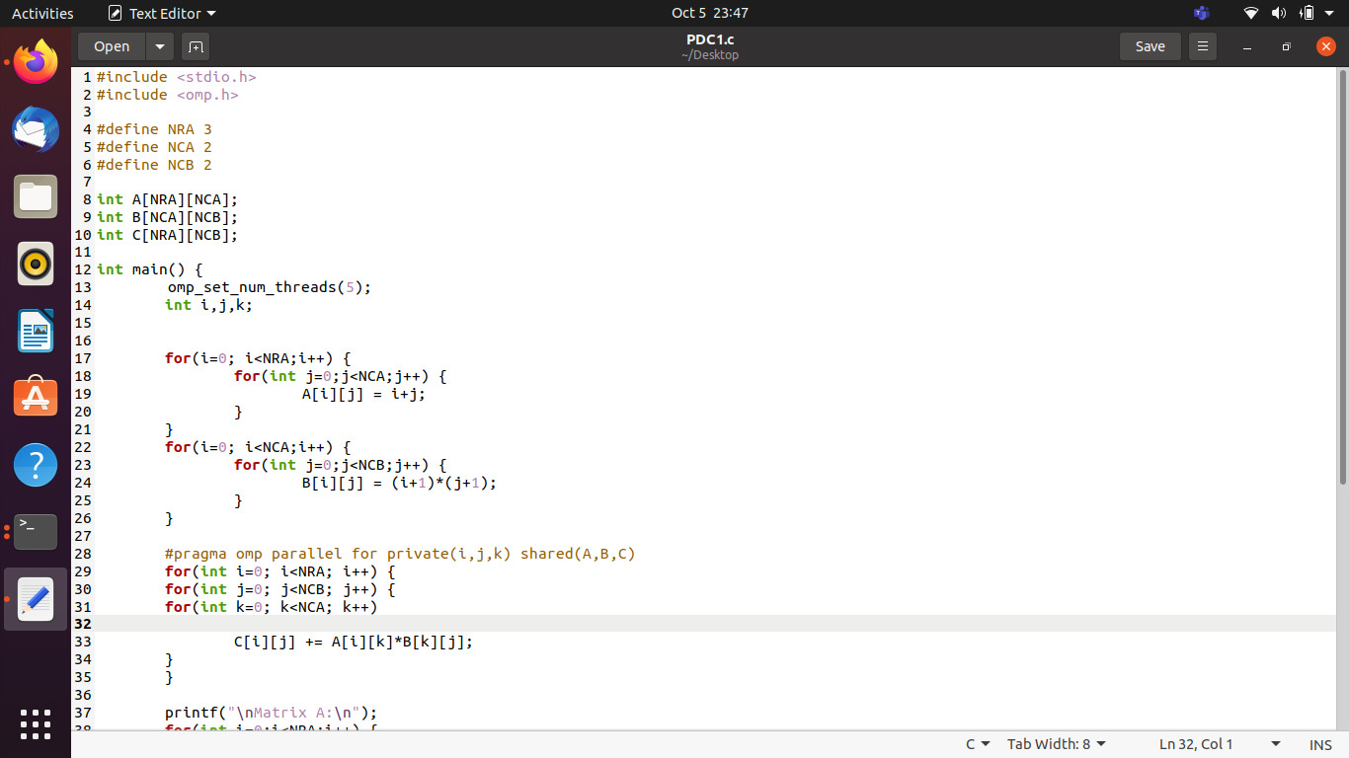

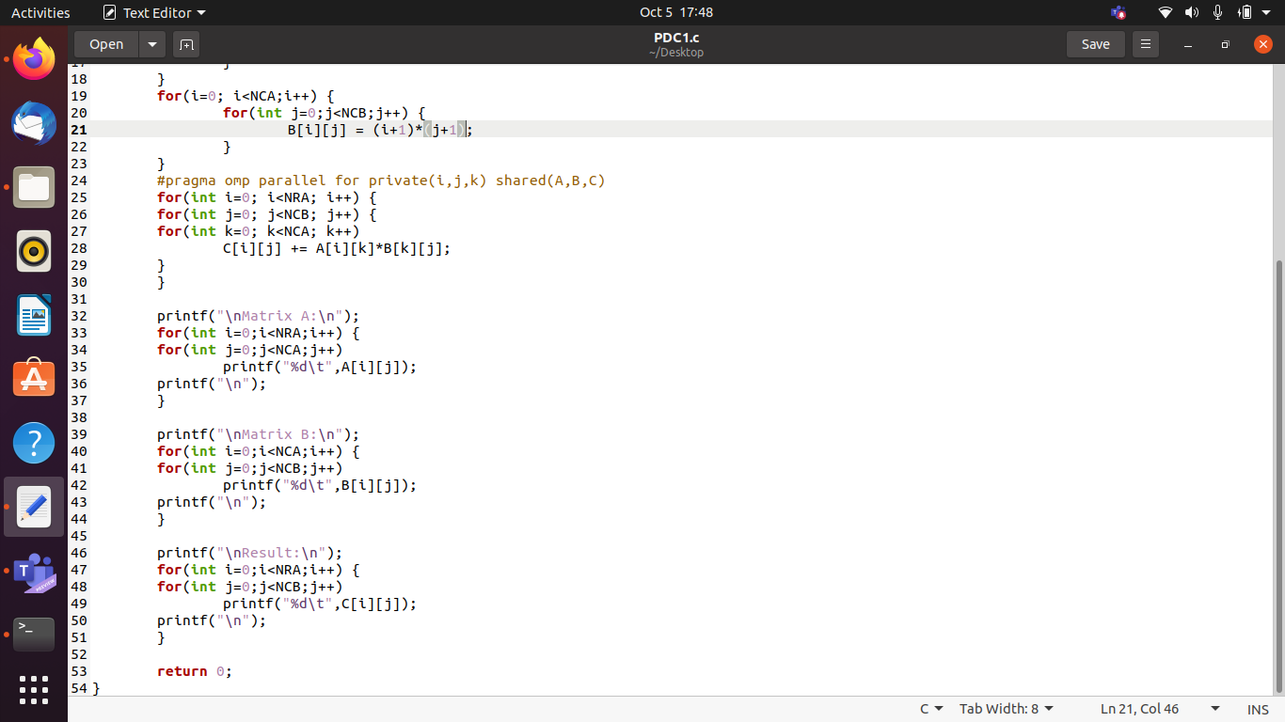

# OUTPUT:

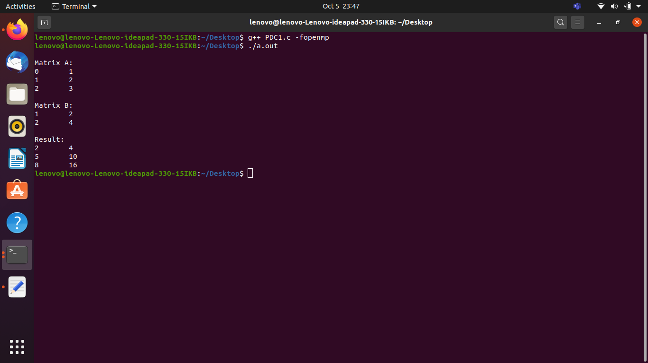

**OUTPUT WITH CODE:**

# 